Jonathan Pitches in conversation with Matt Kambic on Zoom, 24.2.23
(This interview has been edited for readability, following minor revisions for accuracy and clarification by Matt Kambic - March 29, 2023)

Jonathan Pitches: I wanted to start with the development process. I know you worked with the Boil Up Scheme but tell me a little bit about how the project emerged and indeed how it related to the other work that you’d done on Everest, your novel for instance?

Matt Kambic: First of all, there’s no real connection between the novel that I wrote and the play, other than Mount Everest being an always interesting topic for me, so they’re separate and they didn’t happen because of one or the other. But I have dabbled in writing and film and art and music, writing music, so I just pick a spot (I’m retired so to speak) to work on something. I had the idea that the top of Mount Everest would not only be an interesting place to do a play, but would be an interesting thing for any audience to see, maybe even in a museum where you could go into a cold chamber and experience an exact replica of it in the temperatures with the wind and the snow. So partially it evolved from that idea but then I immediately thought ‘wow this is a play that could fit into almost any space’, depending on how much of the mountain you showed, and then you have these two famous gentlemen who climbed it. And then a fellow writer, Sarah Johnson, here in Raglan, New Zealand where I live, mentioned that the Meteor Theatre's Boil Up Programme was soliciting for ideas from new and emerging playwrights. I submitted my idea and they selected it with 10 other play ideas.

I hadn’t worked in theatre; I’d worked in film but had never worked on a stage production before. Boil Up participants were taken in and had an intense initial workshop. Mentors, various sessions, actors from Auckland coming down– and I might be getting a little bit ahead of myself here Jonathan, you'll let me know?

JP: No. It’s great.

MK: Okay. The Boil Up Programme allowed us to really begin to see if we were viable candidates to go ahead and go full on with a play from writing to staging. I loved every minute of it. There were actors, professional actors who had done TV and film, theatre, speaking the lines I had written and practical, good advice from the mentors.

So to summarize the path from A to Z: first would be my personal interest in Everest, interest in the mountain's geology and history and the people associated with it, and then the realization that ‘I could really do a play with this’. And then once you start to delve into the lives of Hillary and Tenzing you can see there’s rich material to work with.

JP: I think I’d imagined that you’d drawn on your original research that was part of the novel to work on the drama, so that is interesting. How did you go about weaving the verbatim material, the quotation from other literature at that period, the historic statements which were made by Tenzing and Hillary into your active imagination and dramatic creation?

MK: I would say first of all I’ve always been a student and fan of mountaineering literature all the way from Maurice Herzog, who wrote the mountaineering classic Annapurna. My parents had the book around our house when I was growing up in Pittsburgh, Pennsylvania. My brother Robert served in the Peace Corps in Nepal so that was an additional connection to Nepal itself. So mountaineering was already a subject that I loved. I’ve read copiously on the Everest stories, the K2 stories, Himalayas, met Ed Viesturs, who had summited Mount Everest (he’s an American climber who’d done all fourteen 8,000 metre peaks). So I had a foundation of interest in that subject.

One of the first flags for me that this could be a truly compelling story was when I started to hear about the controversy about who got to the top first. You can see there’s a great deal of material culturally. So I had a ‘hook’, and the more I got into it I realised, here are two individuals, who I could see were good, hard-working, honest, down to earth gentlemen thrust into fame for something they never could have suspected would transform their lives as it did. They just met on this peak up in the wind and came back down and the world had changed and they had changed.

And just to clarify again nothing from the novel Everest Rising has anything to do with that famous 1953 summiting. It's a science fiction novel where I can reveal the plot to the world that the earth is pregnant. [Laughs] So yes, I already had somewhat of a foundation of research in mountaineering and those characters but as I got into it more and more and read really a tonne of volumes, the play's possibilities deepened and widened. I acquired twenty to twenty-five different volumes along with the web, you know, to tap for more information. I was very careful to try to anchor into what actually happened on summit day, especially.

JP: I have to say I really like that. I know in some of the reviews there’s a suggestion that that gives you a challenge - to get the balance between a believable register of speaking and a heightened register - but I personally really liked the sense that these characters were both human beings and also ciphers and had that weight of literature behind them and were able to cite it at the same time as being in a human interaction with one another. It felt to me a really interesting liminal space between those two things.

MK: It was interesting once I tried to recreate the main set piece. I actually wanted to build the summit identical to the geophysical Mount Everest summit and then I discovered it’s just this kind of 'plain' round top. I don’t know if you’re familiar with it Jonathan? It’s almost like a softly rounded-off tabletop, hardly any rocky features at the very peak. I needed spaces for the actors to move on with stability, so we had to create flat platforms amongst snow, ice and rock-ish features. Plus, we had the usual budget constraints. The original way I wanted to build it, the first quote was for $30,000(!) to fabricate it using a metal substructure with the ability to roll on hidden wheels to pivot, rotate, all kind of cool stuff like that.

In the second and third act I drew from the many different opinions, research, theories, and historical record and then allowed the actors (and their characters) to be a mouthpiece for this abundance of issues, but without ever inferring it was something that they wouldn’t actually say or feel. And I think I was able to pull that off, at least to my satisfaction. Reviewers seem to generally agree, although if you read the one review the gentlemen suggested that I was trying to drop in these actual quotes from the real Hillary and Tenzing and mix it up with my more kind of Kambosian loquacious talk. That was interesting to hear and useful knowledge in the learning process too.

JP I am interested in this decision to cut the top of Everest off and bring it onto the stage. Tell me a little bit more about that decision? I understand the geophysical precision that you wanted and the affordances that that sort of space allowed you dramatically, but taking one step back from that, did you think of anything else? Were there other ways of realising Everest? Or was that always an immediate sense that you needed to start with?

MK: That’s a great question. There were theatre people who suggested I could just put a white block there. One of the mentors said you should be able to do any play with, you know, the simplest of sets and I didn’t disagree but I just personally was passionate and in love and enthused about the idea of having people walk into that theatre (and we kept the theatre unheated for the first act) and feel like they were right there, at the summit. I hoped to realize an environment in the black box, for the first act especially, by establishing the fog and the wind and the cold so that it was as if the audience were back in time witnessing Tenzing and Hillary at the moment of their triumph!

I think that’s what drove my initial idea for the mountain set piece and, again, not being from a theatre background I wasn’t compelled to go into more stylistic directions necessarily, even though we ended up with this stylised mountain since we indeed had to get something built, both for on-the-summit rehearsals and the fast-approaching play season. It ended up being a combination of as real as I could make it within the budget and the time and all the other things we were dealing with.

I thought whatever I do in the first act will set kind of a stirring, evocative atmosphere for both the actors and the audience, and the second two acts would also play out there, with minor between-act changes. We didn’t have the ability/time to change the set in major ways between the acts, but I was quite happy with what we engineered.

JP The decision to just present the summit gives you that very clear and spatial way in to, you know, the fact that you can be in two countries when you’re right on the top and you play with that don’t you?

MK: Yeah.

JP: How far was the geopolitical element of the play or indeed of Everest itself and many, many other mountains important to you?

MK: Well, my play is all about Mount Everest; I don’t think I was thinking of doing a mountain play or thinking too much about mountains, generally. I wanted to bring Everest, Hillary and Tenzing to the audience in as authentic a manner as I could, especially for the first act knowing it really wouldn’t, cause any major hiccups in carrying the rest of the story through that I wanted to tell.

We did spend a chunk of money on a Himalayan mountain backdrop that was really quite large. For the opening of the play we projected onto the backdrop that famous snapshot of Tenzing on the summit that Hillary took. I wanted our Tenzing actor (Jericho Nicodemus) to be positioned right next to it so when the lights came up the photo would fade out and the spot fades up on Tenzing in the same pose, with our Hillary actor (Cameron Smith) crouching to take the iconic shot, and we really nailed that.

So I keep coming back to the fact that I just loved the top of the mountain and the summit day recreated authentically and that’s what I did with it.

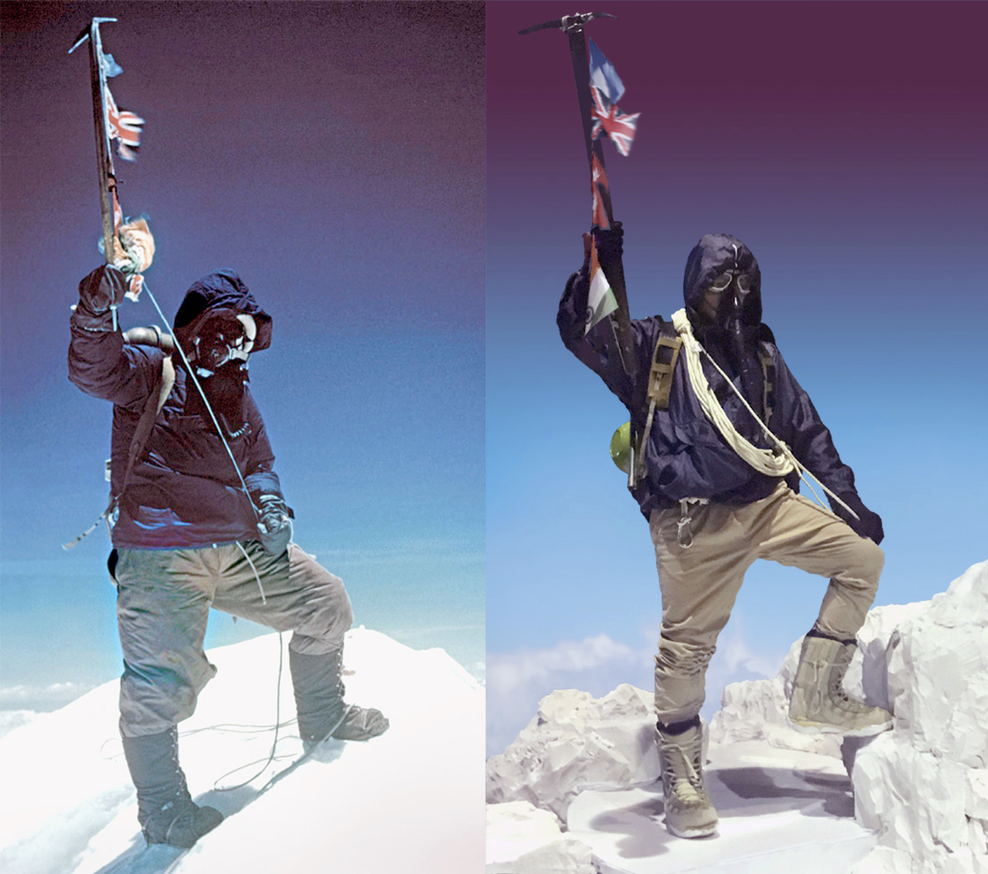
Tenzing Norgay (left) and the staging of the same event with Jericho Nicodemus (right) ©Matt Kambic

JP: I was thinking about the dramatic and political element of that choice. That borderline, I mean they’re standing in two separate countries aren’t they?

MK: What that came out of was, again, the story; there were these great opportunities for mini set pieces within the narrative such as when they’re making the tea and the tea is knocked over the back of the peak and Tenzing says one of my favourite lines (Jericho really did a nice job of milking it): ‘Our stove now in Tibet’. That line set up one more element of the story of Everest that’s fascinating. The country of China generally wasn’t (and isn't) too happy about summiters stepping into their country without, like all of us, a passport or visa, like all countries today. Up there you can step over the border and run around in China and Nepal in a circle if you want on top of Mount Everest. That moment came more or less out of the story writing through the research, using that boundary, that political line separating countries, but it also turned out to be a key thing at the end when Tenzing reveals he was born in what’s now considered China because everyone was fighting over whether he was Nepalese or Indian and in the end it turns out he wasn’t born in either place…

JP: And is that true Matt? That was news to me.

MK: It is true. The thing is those areas in Nepal, back then, there wasn’t a precise border, no Google Maps There weren’t armies coming in to worry about this kind of frontier because it was so, you know, desolate. So Tenzing was born, apparently, according to sources I reviewed, in a village that was on the north eastern side of Everest which is definitely China, or was then Tibet, and is now China. But he wasn’t born in India or Nepal. This was fact was reported a few years after the climb but it never really anchored in the public's recall of the event. So I believe, yes, that’s factually correct as far as any research I was able to do.

JP: And it provides a nice reveal once you’ve laid out all the complexities before in the play, the multiple identities and the irony of that?

MK: Yeah, as well.

JP [Laughs] That’s testament to the way in which you’ve woven the historical documentary detail into the drama because I did genuinely learn quite a bit. I mean I was aware of the controversy around the summiting and I know there’s an incredible literature there just in that one moment, all being generated by that one moment. So I genuinely learnt a lot from the detail that you’ve woven into the drama, which I really enjoyed. Perhaps most striking is that conceit, the dramatic decision that you make, to resummit and resummit again and then take us through both of their lives through time. How did you come to that decision? Where did that moment come and what did you think it would give you?

MK: Yes, it's interesting. One of the reviewers thought the mountain 'had become base camp' for one of the second or third acts, which was not correct from my point, but when you’re in a fantasy future anything goes that serves. I was kicking around some ideas and challenges, one of them was what am I going to do in these other acts that continues the story in this place, on this peak? Shall I bring climbers up to the top from the many who have climbed it? Should Mallory appear as a ghost and talk to them for a while? Should I bring in modern day climbers? Perhaps Lydia Bradey, who was the first woman to summit Everest without oxygen? She’s from New Zealand, but there was a controversy because she had left the permanent party that she was supposed to stay with and gone up by herself and didn’t have a shot, a camera shot of herself, and so she was put down, with other climbers dismissing her effort.

But in the end it was just the reality that there’s a lot to tell here, I really don’t want to set up an Everest Base Camp or set up a city. I mean I could have, I could have said ‘here’s a meeting in a café in Kathmandu or in Auckland’ because Hillary and Tenzing did visit each other from time to time but the mountain was there, with its own presence, and we did augment the mountain set piece in Act 3; we dressed it with some of the climbing junk that has ended up there. So, it was a pretty easy route to go once I realised the story’s about the characters anyway; I don’t have to bring more theatrical elements in when their story is going to work. If I could write it well enough it would hold its own. I wanted to get to the writing. I might have even drafted acts 2 and 3 somewhat and said ‘what else can I do with it?’ and then dropped those additional theatrical options.

JP For what it’s worth I really like that; it’s the bold reality of the decision you make at the beginning to start on the summit and it makes us view all of the developments and the controversies through the lens of the summit in a simple but really quite effective way I thought.

MK: Thank you for that.

JP: You make a decision to improve the weather in Act 2 and Act 3? Was that a gentle nudge towards global warming or was something else going on? Can you tell me a little bit about that?

MK: Originally for Act 1, I wanted the actors to be really suffering more, I wanted higher winds, I would have preferred flags really rippling, actors struggling, gasping for breath. And a colder theatre. We had a small fan behind the flags that Tenzing was holding up. There were technical issues and if I was ever able to mount it with a bigger budget I think at least for the first Act 1 would really try to nail the atmosphere even more so, to approximate the conditions more accurately. For Act 2 and 3 it wasn’t an attempt to show climate change necessarily. I set them in the future, I said they’re back up here in a future so it’s all fiction at this point anyway; if I put them in their full gear and they’re supposed to be freezing again how are they going to have these kind of semi-casual cordial and non-cordial to and fros? So that came without a lot of thought. I also used costume changes to imply it’s more like a day hike they’re taking. And then in the third act they’re dressed almost business casual, as they say.

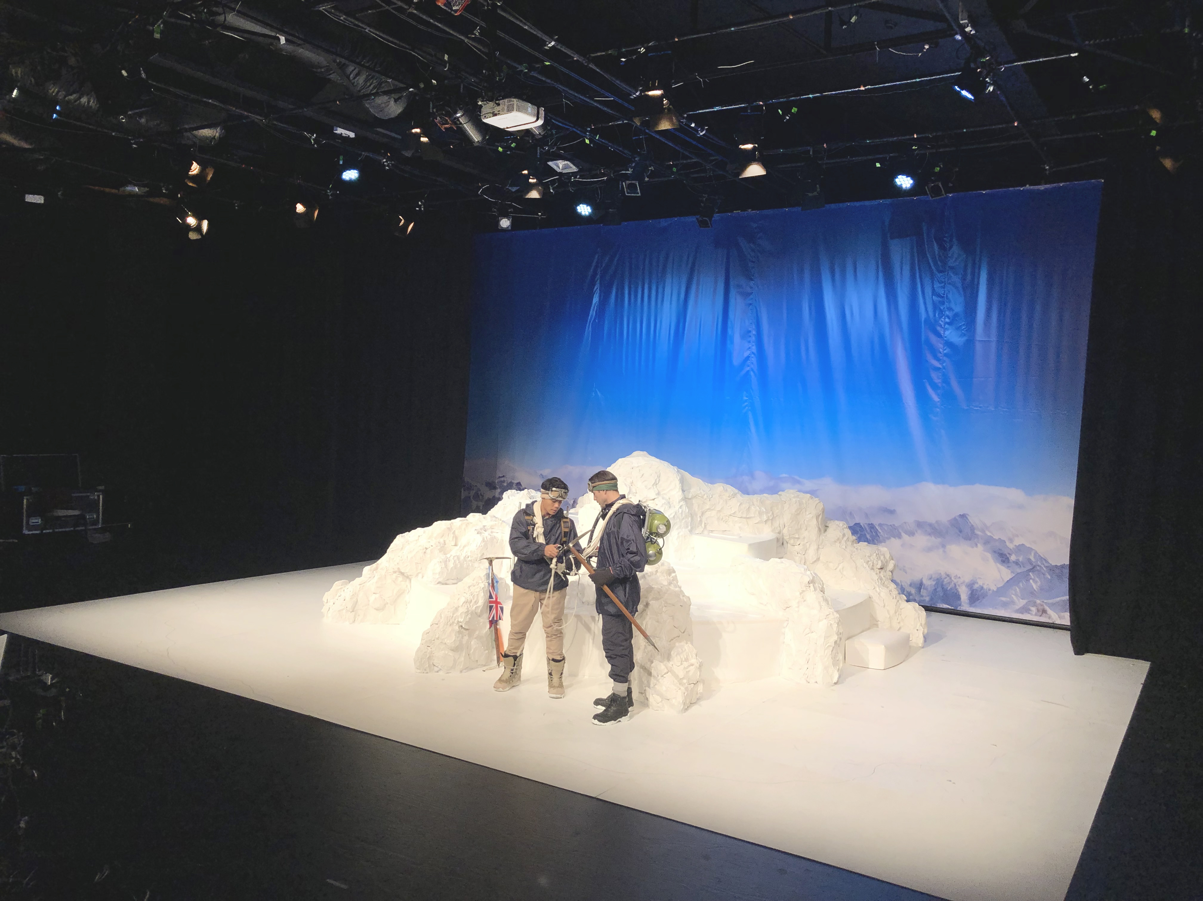
Tenzing and Hillary onstage at the Meteor ©Matt Kambic

JP: I suppose it heightens the surrealism of the time choices doesn’t it?

MK: It does. And I should tell you: there were voices in the mentoring suggesting I forget about trying to make Everest 'real' and go with different states and set pieces and stylised things, and that’s all good, they’re not bad ideas but they weren’t what I was meant to do. [Laughs]

JP: No, not at all. I was reflecting on the visual picture because I haven’t had the pleasure of seeing it onstage sadly but have seen a number of the images you generously shared. It’s very much the thing that theatre does so well which is to celebrate this juncture and make sense of it in your own space at that moment. It takes you from the well-known image of the photograph itself on the summit into a more and more extended fiction effectively as they’re in warmer climes as we know they wouldn’t be.

MK: Another staging idea was to put the mountain in the centre and have the seating in the round. That’s when we were thinking of getting a revolve to turn it. And the interesting thing about that was the audience would then be looking up at the mountain like most of us have to do and the players would be on it. Again we couldn’t practically do that in the theatre we were in so…

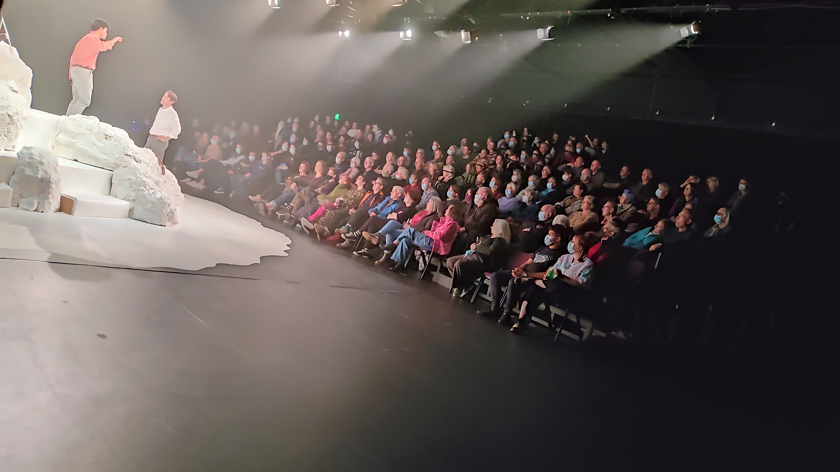
The Sherpa and the Beekeeper at the Meteor ©Matt Kambic

JP: Let me ask you this question- It’s about this notion of decolonising. I don’t know if this is a term that you’ve come across a lot? It’s certainly writ through a lot of the conversations I have as an educator in the UK at the moment. This is the notion of going back to historical moments and revealing the assumptions and political investments that are embedded in them. The project that I’m writing for, Other Everests, its key thing is about decolonising the archive of Everest, the wider Everest archive and that connected to the Royal Geographical Society. They’re trying to give the voice much, much more firmly back to the Sherpa community - to recognise the deaths and the unvalued labour that has hirtherto underwritten the history of Everest climbing. I felt that you were doing something similar dramatically, that you were reassessing those voices and trying to balance them out in a different way. I don’t know whether you would call it decolonising or whether you would resist that entirely but do you mind just commenting on the voice of Norgay and what you felt might be important to value in different ways in this play that might have been done in the dramatic record before?

MK: I think you probably hit the nail on the head as far as where the play ended up going. I didn’t necessarily plan it that way. I wanted to recreate summit day but then once you discover this ‘who got there first’ thing, the rest of the stuff and the colonial nature of the mission, the assault on Everest that was mounted by Britain versus what the Sherpa experienced when the victors were marching off the mountain towards them and what they were hired to do, you could just see – and I tried to bring that out in the play quite specifically – the Sherpa weren’t considered... what’s the way to say it? Really able to understand what the British were doing in this grand moment.

Now that’s not to say that individual western personalities didn’t have different feelings on it; some of them said, you know, ‘we’re not treating these Sherpa really equally’. It probably wasn’t on their mind a lot. One of the things I think it’s always important to remember is there’s the construct we grew up with in the 40s and 50s when these British mountaineers were growing into adulthood, they weren’t taught to worry about racial equality nearly as much - it wasn’t imbued in them. Their parents may have been honest people and said ‘don’t treat anyone differently’, or whatever. They came into life, and the expedition, with a set of values that trickled down from ‘on high’ as all of us do.

And so I always look at it as a situation where the Sherpa were not treated equally but there’s not necessarily individual blame to cast, and especially with Hillary and Tenzing, you know, two really pragmatic guys, Hillary from New Zealand, a beekeeper, not as high-society as some of the British. And to be fair, when I’ve read all the different comments from the British mountaineering team, they never talked in a way that put down the Sherpa, but tellingly they seldom talked in a way that treated them as equals. It was ‘the Sherpa were so good about helping us, strong people, you know, always up to the task at hand, grinned so much, cheery,’. After a while you just start considering that they're almost making a cartoon out of a human who might be thinking (in reply) ‘you really don't get it, you know; we're helping you sahibs every day and all you worry about is getting your name in the paper’. So you really didn’t hear that kind of clash but you assume it had to be taking place in some respect.

To answer your question it was quickly apparent that I could take Hillary and Tenzing, guys with good hearts, unassuming, and present some of these larger issues in an updated context – how we currently reconsider stuff in history that has occurred. I tell people that for me the apex of the play is when Tenzing leans over and says to Hillary ‘think of the word Sherpa... now think of the word Shepherd... now think of the word Chaperone... maybe even Babysitter!’ and instead of Hillary saying ‘You’re crazy man, what are you talking about? You know, we’re the British’, he accepts this profile. This ‘new’ Hillary I was creating was someone who could realize what Tenzing was saying was not wrong. But also, if I wrote it semi-effectively, the character is not tormented because, again, he understands he was brought up in that cultural construct I just mentioned and so realises that their friendship and their deed together is a bond that can override this situation as they navigate their way through it.

I always told my actors that for most of the play I was having them fighting their own feelings; they had to throw (verbal) things at the other guy to clear the air and make sense of what had happened to them.

As I stated I referenced a lot of material to properly, and authentically, consider these famous characters, orient the drama. One really significant book, covering the cultural gulf, was Imperial Ascent by Peter Bayers. It delves right into the nitty-gritty of the race issues and the imperial aspects of what was going on back then with the Sherpa and the British. And there’s also other mountaineering and adventure episodes in the book that speak to the same issue.

JP: You make a decision don’t you to improve Tenzing’s articulacy as he goes through the play so that he becomes more and more able to express himself in quite, you know, complicated language, ‘hyperbole’ is that nice moment isn’t it?

MK: High-per-bowl-lee, yeah.

JP: What was the purpose of that for you? Was it just an important arc for the actor or were you saying something more about time, history and its connection to language?

MK: It’s a combination of things.

Interestingly, when I did the first sample of the first few minutes of the play for the other Boil-Up participants there was a sense that I had to be careful about the language. There were Māori people in the audience, members of the sponsoring and mentoring team, telling me about how they’d had to deal with situations where if they’re not talking in kind of elegant or sophisticated Western languages, there’s the put down of them right out of the gate. And it was suggested to me that I had to be very sensitive about the way I had Tenzing speaking in broken English. One of the main candidates who I approached to play Hillary didn’t want to do the part because of that and actually said that I might need sensitivity training. I replied that ‘I don’t think you know me sir. I want to investigate and expose this problem in context and dramatically, in some ways I want to use the ways of speaking for the very purpose of highlighting how mispronouncing in a given language has helped foment racism’. (The actor was well-intentioned and I got a great guy to play Hillary and it worked out.) I wanted to establish Tenzing's evolution as a human, as well as I might, but also indicate his pre-existing, genially-centered brilliance as a climber, friend, and expedition leader. He knew all those languages! At one point in the play you can watch as Hillary is reeling off all the languages that Tenzing already knew when he was hired to become the Sirdar of the ’53 climb.

I just wanted to show his (and of course Hillary's) evolution in an act-by-act manner. So, I was reflective about the 'broken english' but he did talk in that way (I don’t know another word for it). Again, in the first act I wanted to be as authentic as possible. What I attempted was to address the movement forward in time, in the next acts, with the appropriate transformations. Tenzing became more 'well-spoken' in English (and if you’ve ever read his biography Tiger of the Snows co-written with an American, I believe, Tenzing’s very articulate in there, so I don’t know if it was translated to be that articulate or not but he’s quite nuanced in his verbiage). I also believe he was an intelligent man and so for my western audience – and for me – I thought it was fair to reveal that intelligence through his speech; vocalizing in ways maybe he never actually used in the real world, but I supplied to the audience so they would see that he could have.

JP: That makes a lot of sense to me. And what’s the arc for Hillary? What’s the character development there? Are you trying to build his character from ’53 on, to 40 years later?

MK: I always remember he was never quite in the inner circle of the 'British Empire' mission to assault and conquer Chomolungma. He loved mountains, jumping around in his life to get at them; but he was expecting to go back and become a beekeeper again, and so he was really thrust into a spotlight that he was maybe even less ready for than the other guys on the climb. John Hunt and the other expedition members weren’t necessarily ready for the fame and everything it entailed either. But for Hillary I wanted to show how he could be a bit less easy-going and occasionally ticked-off about situations. Not always, of course, but occasionally. I read a thing that while at one of the camps before the summit climb, someone was taking a picture of him and he was sitting reading and he said ‘put that camera away or I’m going to break it’ or something like that.

Hillary didn’t over-fuss about things. You may know that Tenzing rescued him from a crevice some time in the few weeks before the summit climb and Hillary said something like ‘yeah it was great that Tenzing was there’; he didn’t do this Jon Krakauer thing where ‘oh I prayed that Tenzing would be there for me and I clutched him deeply when I was rescued’. There’s none of that drama. He was a regular kind of guy, clearly liked the climb, did the climb, ‘knocked the bastard off’, came back down and then one of the first things he heard when he was back in New Zealand was that Tenzing had told the king that Tenzing got to the top first. Now whether Tenzing actually did that (I don’t think he did but the king may have heard it or the king may have said it anyway) I don't know. There’s another thing I read where Tenzing’s family apparently reported that Tenzing actually told them (kind of on the sly) that he, Tenzing, had gotten there first. But the two guys agreed not to tell anyone, they knew, you know, it was better not to do that.

What I tried to do with Hillary is take him through the emotional grinder of ‘Man, I did get to the top first – but I shouldn’t really be worrying about that, I’m a regular kind of guy but I’m ticked off a little bit, you know. Tenzing is such a good guy. Why'd he do such a fool thing.’ He's bothered that he's bothered by any of this, doesn't like that he should be feted for just doing his job, likes that he is feted, and can't get his beekeeping head around it all.

In actual fact, they didn't meet regularly after May, 1953; so I bring them together. I get to use flashpoints, churn those right up and put them front and centre for the audience and the characters.

So, for me Hillary’s crux occurs as he's marching around the mountain declaiming about the quest: ‘We the British, we came in and took your firewood and yaks and your best Sherpas, and we said get out of the way’. So Hillary was trying to flood his senses with the worst aspects of the climb almost to the point where Tenzing could then bring him back down a little, saying ‘Okay, you know, you guys did a lot of that but you weren’t, like, terrible, you weren’t like slave drivers’. And what I also attempted to do, at the end, is bring them back to where they were at the start, good, even humble men, which I think they both ended up being in their lives, with the mantle of fame and what it brings, good and not good, draped around their necks.

Hillary went back to Nepal and engineered the building of hospitals and schools and bridges; he did all these wonderful things. Tenzing’s life afterwards wasn’t so good, he started a Sherpa climbing mountaineering school, in later years he became an alcoholic, but I still think he had an inner 'Tenzingness' that shone through much of his life.

With Hillary, as far as a character arc, it would be the revelation of him facing the worst trials of fame, yet still pulling the goodness out of what happened and the worth of it in the end, yes.

JP: Thanks Matt. That’s really enlightening. It comes back to an earlier question I wanted to ask you and didn’t, which is the job that you needed to do as a director to work with the actors to enter the world of the mountain. They’re pretty exposed out there aren’t they just the two of them and obviously they can riff off one another? But how did you take them on that journey? How did you train them to develop their characters and indeed to be steeped in that history? Did you give them research tasks? Did they research their own characters? How did you lead them into that experience?

MK: So I feel very fortunate because we sent out an audition opportunity online (and got a relatively modest amount of hits) and we were in Hamilton so many possible actors would have to come in from Auckland or submit a video clip to us.

But the gentleman who showed up to do Hillary was a guy who had done a fair amount of theatre, he was in his 40s but he looked younger (Cameron Smith), he was a professional about acting, even though he was doing a day job in New Zealand like a lot of actors have to, you know, you’ve got family and kids. He knew the Everest history, he cared about the history, he brought suggestions; he was one that suggested at the play's end that I have Hillary join in saying the poem that Tenzing was reciting (written by Wilfred Noyce). Cameron suggested ‘how about if Hillary remembers it, you know, and they start doing the last poem back and forth, taking turns?’ And that was beautiful at the end and he had other useful suggestions.

I had directed a low budget science fiction movie, I had directed professional videos for universities in the US, but I hadn’t worked with professional actors a great deal. I got two excellent actors. I had a mentor from the Boil-Up (Mel Martin-Booker), a local director who helped out; she’d come and advise at some of the rehearsals. I had two brilliant production managers (Jay and Brooke Baker). The guy who played Tenzing was a 27-year-old gentleman who had done a fair amount in NZ, he had played one of the Power Rangers, he was a stunt guy, he was also great.

What happened is Cameron/Hillary~Jericho/Tenzing started to develop a relationship I think that was somewhat akin to what the two climbers had. Cameron was the more versed professional who was coming in and knew a great deal about theatre, and Jericho was also talented but younger, smiling, exuberant, and maybe would miss a rehearsal start time here and there. Maybe that part is not true of Tenzing but, let's say some of the stuff that was happening with them as characters was happening in their real lives.

I’ll tell you the honest truth Jonathan, I think I was able to step back pretty easily. There’s a lot of dialogue in this play; I wanted to make sure they spoke it. But I just wrote whatever I wanted [laughs], not considering the degree of memorization it would take. Like Jericho said ‘I was sleeping with the script on my face, hoping to learn some of these lines by dreaming about them.’

I didn’t feel like I had to do a lot of directing. I just wanted to make sure a couple of things came off more specifically. I wanted to make sure that Cameron didn’t push Hillary into a lot of fronted up anger or antagonism; let the words speak to his disjointedness about the situation and then maybe in the last act he can power up a little more. I didn’t want it to be just that they have this glorious first act and then they’re kind of beating each other up for the rest of the play. Cameron nailed a remarkable Hillary, as the reviewers noted. I tweaked a bit here and there, but not much.

And for Tenzing/Jericho, he did a beautiful job, including some of the extemporaneous acting. I had him read out a Nepalese play, he leapt to the top of the mountain, stood up and started to do a little bit of this and that adding verve and spirit to the moment. Fabulous. After a point I just watched, enjoying as they took it and made it their own. That was the first play I ever directed.

We put a lot of work in, we had pandemic issues, people missing due to the virus, Jericho had to drive down from Auckland every rehearsal, to Hamilton, it’s about 2 hours and he might get off late from some other production he was stunting for (he did Lord of the Rings work for Amazon's TV show). We got them in gear, then we got them on the mountain for a month. So I didn’t do a lot of directing of these guys, they made it, they made the characters, they worked and played off each other. In fact Cameron had Tenzing doing theatre-professional warm-ups, stretches and voice work. He brought over aspects of theatre that I didn’t know and wouldn’t have necessarily worried about, and he and Jericho, they made it a mission to do those things before every rehearsal and before the plays and it was lovely to watch. It was a wonderful experience really.

JP: They are both highlighted in the reviews as putting in pretty big performances there? You’re being very modest and obviously recognised when not to direct is a really important skill as a director.

MK: You can probably realise this from speaking with me, my background is not in theatre so the whole thing was a joy to be learning, understanding, drinking it in and trying to still contribute, which is mainly by producing the manuscript itself. (Of course, I also directed, helped to facilitate the mountain-building, backdrop Photoshopping, prop creation, costume wrangling, music, lighting and sound effects). I recognized if people saw the play and they didn't race out of the theatre (!) that means the writing is okay and it’s carried the story and all the other embellishments you might bring. There’s a thousand ways to do that but in the end the words in the manuscript are the play, correct me if I’m wrong? [Laughs]

I’ve only got a few more minutes with you so let me ask my final two questions if you don’t mind? To what extent is the environmental destruction of the mountain part of your thinking? You talked about the junk at the end and we’re very familiar with the images now of the dead bodies that are lined up and the huge queues etc. It’s a very light touch that you bring to that. How much was that in your head?

During the third act the scene opens with them sitting and there’s debris pretty well filling up the stage and through the third act they’re carrying pieces around to the back of the mountain and theoretically cleaning it up. Yes, I guess I was depending somewhat on the audience knowing that mess was going on there and it probably isn’t necessarily a good idea, but I had the mission to wrap up, you know, their emotional journey so I positioned the junk there and it’s in some of the dialogue, like at the very end they said ‘we’ll have to come back here and clean this up when we get time, clean up the rest of it’ and as you know there’s been efforts to do that now on Everest. I think they’re paying x thousands or x hundreds of dollars per oxygen tank. The South Col is quite a disaster. That’s where most of the stuff gets left because people are just totally toasted by the time they come off the summit and tents are shredded and their tanks are left there because who has the strength to carry them down? They want to try to live, not carry extra weight on the way down. So I wanted to bring it into the story but I didn’t want it to overwhelm the third act of what was happening with the characters and again maybe I assumed that the audience would realise that a lot of pristine places in the world are getting junked up but Everest is one of the worst just because of the necessity of all that machinery to get people up there.

JP: Could you help me out with your last image and how you decided to conclude the play? Obviously, there’s the epilogue with the projections and then the very, very last epilogue with the actors. You put them just before the summit, they’re back in the wind and the cold and right back to Act 1 and then the slide fades to black and we don’t actually see them hit the summit. Take me through that dramaturgy?

MK: Well one thing I wanted to remind myself and the audience– that it was the climb that made all the rest of this happen and anchor it back into the reality of that day, so that was a nice way to do that. It was a challenge for the stage crew and the actors because they had to change back into the full gear and we had pretty authentic backpacks and green oxygen tanks and masks. But more than anything I thought the lovely wrinkle of getting them ready to go up and the audience anticipating ‘we’ll finally see who did step up there first’ and then just cutting it. So it was probably just a personal urge to do what I just stated, bring them back into the climbing gear, get the Hillary and Tenzing that the public knows from those films and those scenes and then just say it really doesn’t matter, it didn’t matter in the end who got there first and you’re not going to find out anyway. [Laughs]

I mean Tenzing basically said in his autobiography very clearly that Hillary got there a few steps before him. Even so, a lot of people just say that he wrote that to placate and in the play he reads from a book where the two ambassadors decided to say that they both got there at the same time to avoid political repercussions. I have a feeling that, yes, Hillary did get there first, partially because of the cultural stuff we’ve been talking about and partially because it wasn’t in Tenzing’s mind (as he states in his book) to go racing past Hillary at the last minute. Everest was too important and too holy to monkey around with in that way. But still it’s a one time event. It will be like when someone, the first guy on Mars I guess, once you’re there you’re locked into history forever and I think that’s the thing that really blew them away. They knew it would be a big deal but no one imagined it would be a crushing mantle for so long. It’s good they were sort of solid Joes and not, like, if you read about Mallory, he seemed to be ready to really die if he couldn’t do it on his last climb.

JP: I can’t tell you how much I’ve enjoyed this conversation and I’m really, really grateful to you for your time. I will obviously share with you everything that I intend to put out.

MK: Yeah. That would be wonderful. Looking forward. Thanks.

JP: Thank you.

MK: Good luck with all your writing and your book and yes, I’ll look forward to hearing more from you as it develops.

JP: Brilliant. Thank you. I hope to keep in touch Matt and have a good rest of the day.

